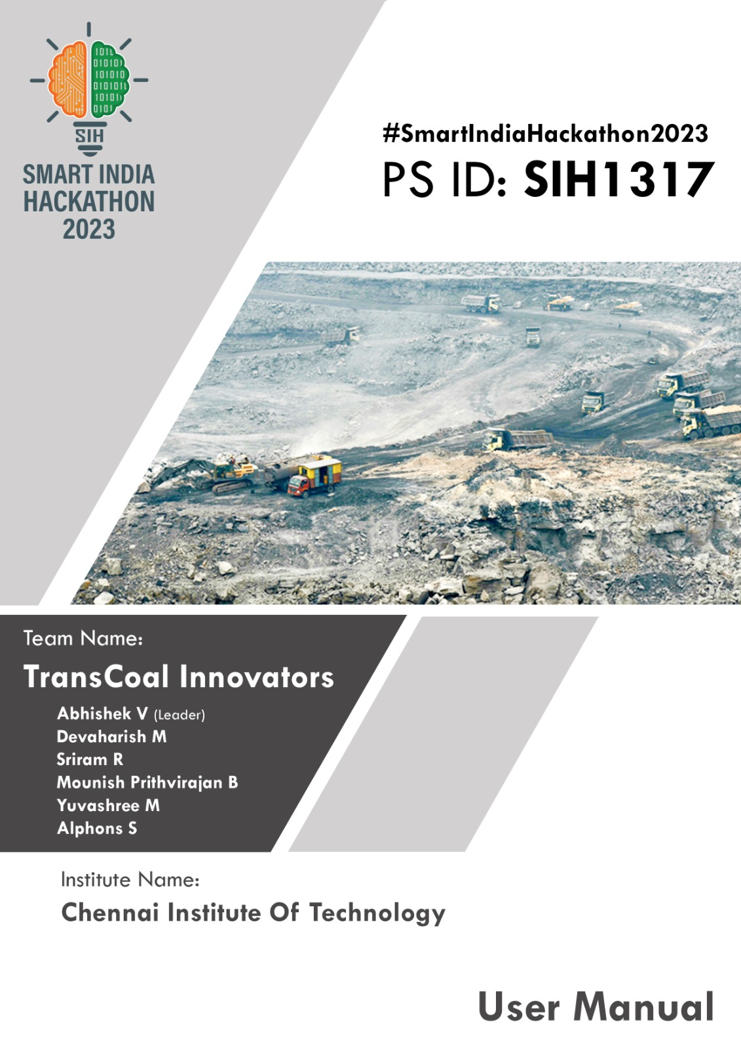

# Abstract

**Title: Coal Logistics Digital Platform:**

**Streamlining Operations for Efficiency and Compliance**

Our aim is to tackle the persistent hurdles within coal transportation by introducing the Coal Logistics Digital Platform. This innovative platform serves as a centralized system, bringing together real-time data streams and advanced tracking tools, all accessible through a user-friendly interface. This integration offers a complete and clear picture of coal movements, eradicating delays, uncertainties, and ambiguities in decision-making processes.

By acting as a central hub, it significantly streamlines operations, trimming inefficiencies, and importantly, ensuring strict adherence to safety and privacy protocols. This transformation doesn't just optimize logistics but also delivers substantial cost savings. Moreover, it prioritizes safety measures and privacy concerns at every step of the transportation process.

Ultimately, the Coal Logistics Digital Platform empowers stakeholders with the tools for well-informed decision-making, cost-efficiency, and a paramount focus on safety and privacy, thereby reshaping the landscape of coal transportation for the better.

**Introduction**

In the world of coal transportation, managing the movement of resources efficiently has been a longstanding challenge. The absence of a centralized tracking system has led to delays, confusion, and a lack of transparency. To address these issues, we propose the development of a dedicated Coal Logistics Digital Platform.

Our platform aims to revolutionize the coal transportation process by consolidating real-time data from various sources. Live tracking data and smart monitoring tools will be integrated into a user-friendly interface, providing stakeholders with a comprehensive overview of coal movements. This centralized hub will offer clear insights into the location, status, and progress of coal shipments, eliminating confusion and enhancing decision-making.

By bringing all relevant information under one digital roof, our platform ensures that operations become smoother and more transparent. This not only accelerates processes but also contributes to cost savings by optimizing routes and reducing inefficiencies. Moreover, the platform will play a crucial role in ensuring compliance with safety and privacy regulations, offering a secure environment for data management.

In summary, our Coal Logistics Digital Platform aims to transform the coal transportation landscape, making it more streamlined, efficient, and compliant. By providing a centralized, real-time view of operations, we empower stakeholders to make informed decisions, save time and money, and prioritize safety and privacy in every step of the process.

**Existing System**

In the dynamic landscape of coal transportation, various tracking platforms cater to specific modes of transit, each playing a crucial role in ensuring efficiency and transparency within the supply chain.

**Ship Tracking Platform**

Vessel Finder and KPLER collectively represent a cornerstone in the realm of maritime coal transportation. Their significance lies in furnishing real-time insights into vessel whereabouts, intricate voyage specifics, and pertinent port details. Vessel Finder, in particular, grants stakeholders the authority to oversee and regulate coal shipments carried through maritime routes. This technological prowess furnishes an expansive overview of maritime operations, facilitating meticulous scheduling and astute inventory handling. Essentially, these tools equip stakeholders with the necessary data to make informed decisions, optimize schedules, and proficiently manage coal inventory traversing through maritime channels.

**Train Tracking Platform**

FOIS (Freight Operations Information System) spearheaded by IRCTC assumes a pivotal role in monitoring the transportation of coal through trains. This specialized system offers a seamless flow of real-time data concerning train movements, schedules, and inventory management across the expansive railway network. By providing immediate access to essential information, FOIS empowers stakeholders with a comprehensive view of coal transportation dynamics within the railway infrastructure. Its functionality plays a critical role in optimizing the logistics of coal transport, mitigating potential delays, and ensuring an efficient and streamlined process for all involved parties.

While maritime and rail channels benefit from robust tracking platforms, a conspicuous void persists in technology catering to coal transportation via trucks on roadways. The absence of a specialized tracking system for this domain poses distinct challenges: limited visibility, probable delays, and complexities in ensuring compliance with safety and privacy regulations. This gap underscores the need for an integrated system to enhance monitoring and streamline the efficiency of coal transport via roadways, aligning it with the standards set by maritime and rail tracking technologies.

**Proposed System**

Recognizing the need for a holistic solution, we propose the development of a Unified Digital Web Platform for tracking and monitoring coal transportation. This innovative platform will integrate data from various modes of transportation, including ships, trains, and trucks. By consolidating information in one centralized hub, stakeholders will have real-time visibility into the entire coal supply chain, from origin to destination.

Our Unified Digital Web Platform aims to bridge the existing gap, providing a comprehensive solution for coal transportation monitoring. With this unified approach, we strive to enhance efficiency, ensure compliance with safety regulations, and offer a seamless experience for all involved parties in the intricate web of multimodal transportation.

**System Architecture**

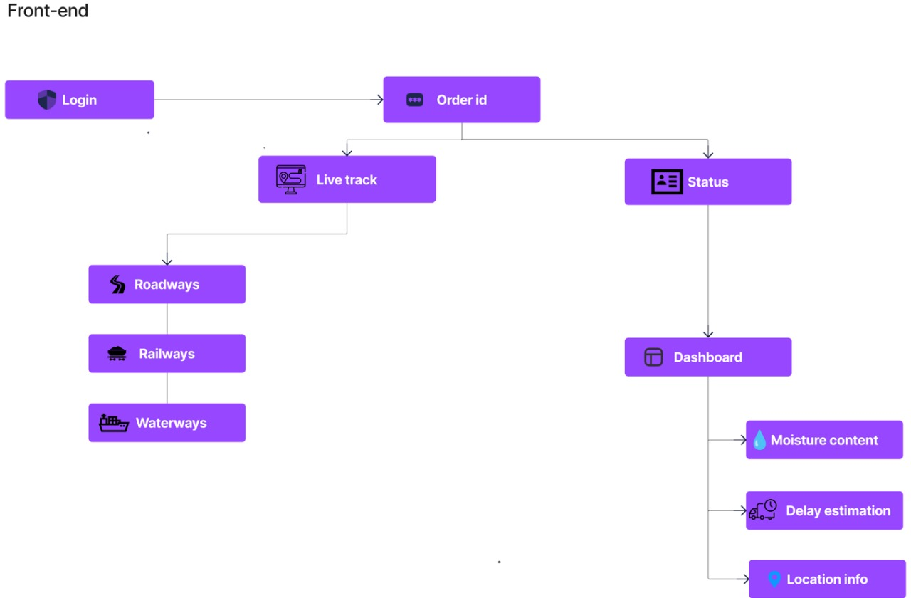

**Figure 1. Front end of the System**

Figure 1 illustrates the front-end architecture of our system. To access it, stakeholders must log in through the login page. After successful authentication, they can input the Order ID for the consignment. Once the necessary details are provided, they can select the live track option, which displays the real-time status and location of the consignment on the dashboard. This dashboard showcases the consignment's movement across different transportation modes: Roadway, Railway, and Waterways.

Within the status option, stakeholders can access crucial details about the coal's condition, including moisture content, estimated delays, location specifics, and alerts for suspicious activities like route deviations, theft, or prolonged halts.

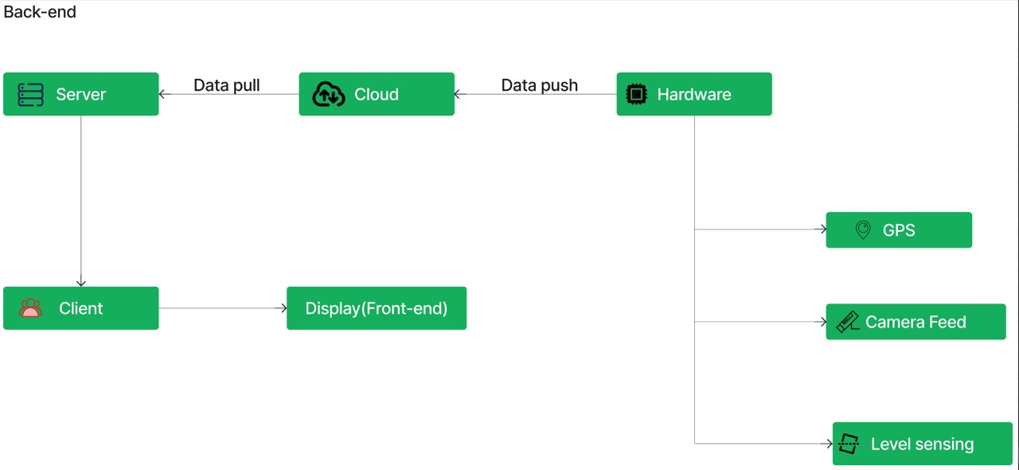

**Figure 2. Back End of the System**

# Figure 2 showcases the integration of back-end components in our system. A Microcontroller equipped with networking capabilities and image processing interfaces with cameras and sensors. It then transmits gathered data to the cloud. The controller identifies suspicious activities like theft, overloading, or lost connections, and uploads this information to the cloud. For our application, Firebase serves as the cloud platform.

# One critical aspect monitored continuously by the hardware unit is the moisture level of the coal. Any abnormalities detected are promptly relayed to the dashboard for notification. The data collected in the cloud is subsequently pushed to the server. All this acquired data is accessible through the client node, allowing stakeholders to view and interact with it on the dashboard.

# Key Feature of the System

1. Unified Tracking Platform: Our solution bridges the gap in the coal transportation industry by creating a single platform for real-time monitoring of shipments across different transport modes (trains, ships, trucks), ensuring seamless tracking and management.
2. Enhanced Security and Efficiency: Revolutionizing coal transportation, the solution prioritizes both security and efficiency. It offers a user-friendly dashboard for secure monitoring, aiming to significantly reduce delays, streamline processes, and elevate industry standards.
3. Image Analytics: The camera module placed in each of the critical points of the coal transportation network is equipped with a machine-learning trained module that is capable of processing the real-time image of the transport passing through it with the coal load.
4. Condition Analysis: Analysis of the condition of the cargo or the health of the coal transported plays a major role in contributing to the loss of the coal transported as parameters like moisture facilitate better transportation.

# System Components

# System consists of

# Dashboard

# Simulation Environment and

# Real-Time model

# Dashboard

# The dashboard showcases data retrieved from both the simulation environment and the real-time model. It presents a range of parameters for display, including:

# 

# Figure 3 Dashboard of the System

# Real-time tracking information of the consignment,

# Live Camera feed from the consignment

# Moisture level of the coal

# Level of the coal

# Theft alert from the camera

# Truck deviation alert

# Simulation Environment

# Figure 4 depicts the Simulating environment of the System

# 

# Figure 4 Stimulating Environment

# To prototype the simulation environment has been created, Although a real-time tracking feature is available with the help of GPS, we cannot see a wide variation in the location, to overcome this in the simulation model consignment movement is simulated, the simulation of the movement of the consignment is available for all the modes of transportation.

# Real-Time Model

# A truck model along with the camera and sensors constitute the Real-Time Model, Video analytics based on machine learning models is used to classify abnormality like theft alert, overload, connection loss, and camera diverted. Figure 5 depicts the real-time model

# 

# Figure 5 Real Time Model

# Moisture level sensors incorporated with the controller continuously monitor the moisture level of the coal to ensure that the coal has the prescribed moisture level otherwise the same will be notified to the stakeholders.

# Technology Used:

MERN Stack (MongoDB, ExpressJS, ReactJS, NodeJS).

Firebase – Database & Server.

Microcontroller (Raspberrypi 4).

Camera Module.

Sensors (Neo 6M GPS module, Moisture level sensor).

TensorFlow (ML model).

# 

# Progress

**The progress made from the first round of evaluation is listed below**

Implementation of the dashboard for trains and Ships.

Improving feasibility of Camera module (installation on critical points).

Developing a business model.

Reducing the no. of child nodes on Firebase from the real-time data.

Developing a machine learning model for monitoring and security.

**The progress made from the second round of evaluation is as listed below**

Multi-modal (3 Ways) tracking using Order ID

Business Model with Profit Estimation

Data Integration at the back end

Hosting back end and front end from local host to domain

# Business Model

Our estimated business model revolves around a subscription-based service offering for our innovative Coal Logistics Digital Platform. We aim to provide tiered subscription plans tailored to meet the varying needs of our clientele, granting access to different levels of features and data insights. Additionally, we plan to incorporate a pay-per-use model for certain advanced functionalities, ensuring flexibility and cost-effectiveness for users. The revenue projection also includes potential partnerships with logistics companies, coal producers, and transportation entities, fostering collaborative growth and expanding our user base. Ultimately, our goal is to establish a sustainable and scalable business model that prioritizes value delivery to our clients while ensuring the continuous evolution and enhancement of our platform. 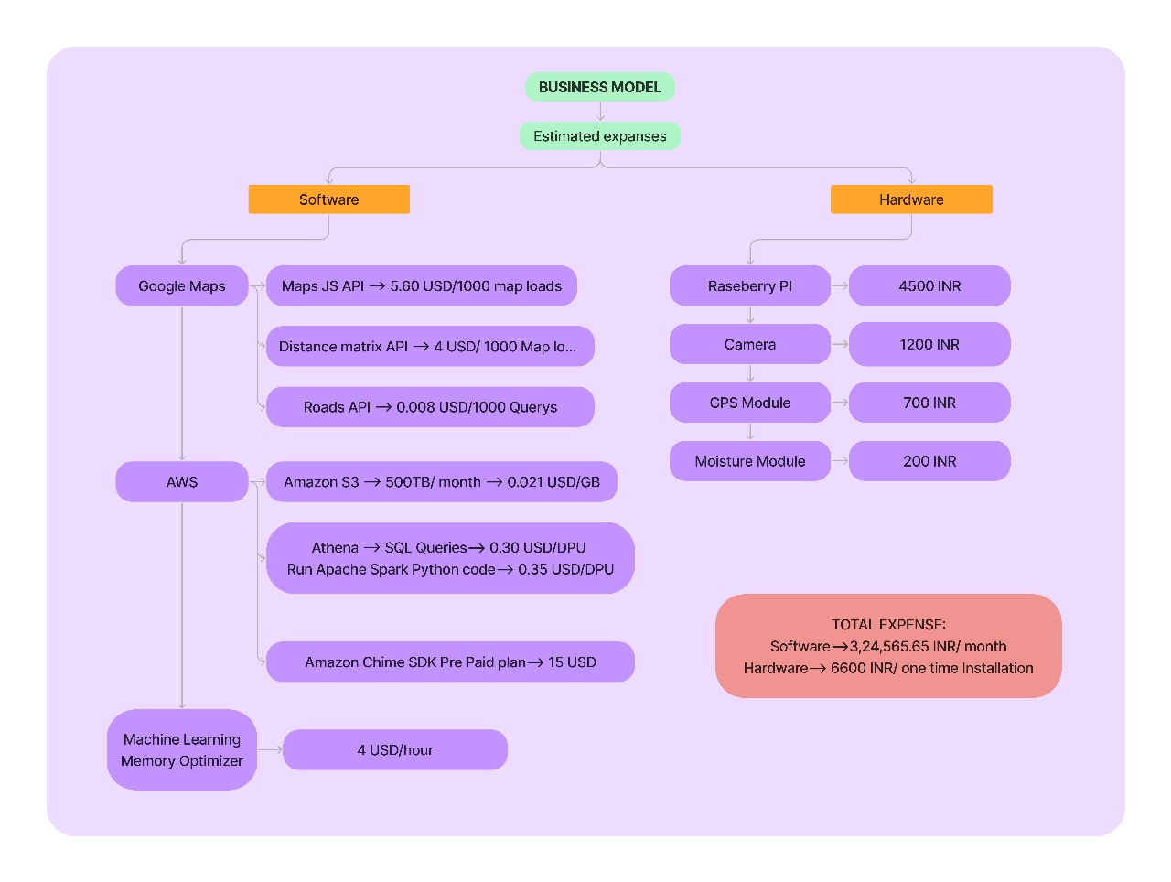

**Figure 6 Business Model**

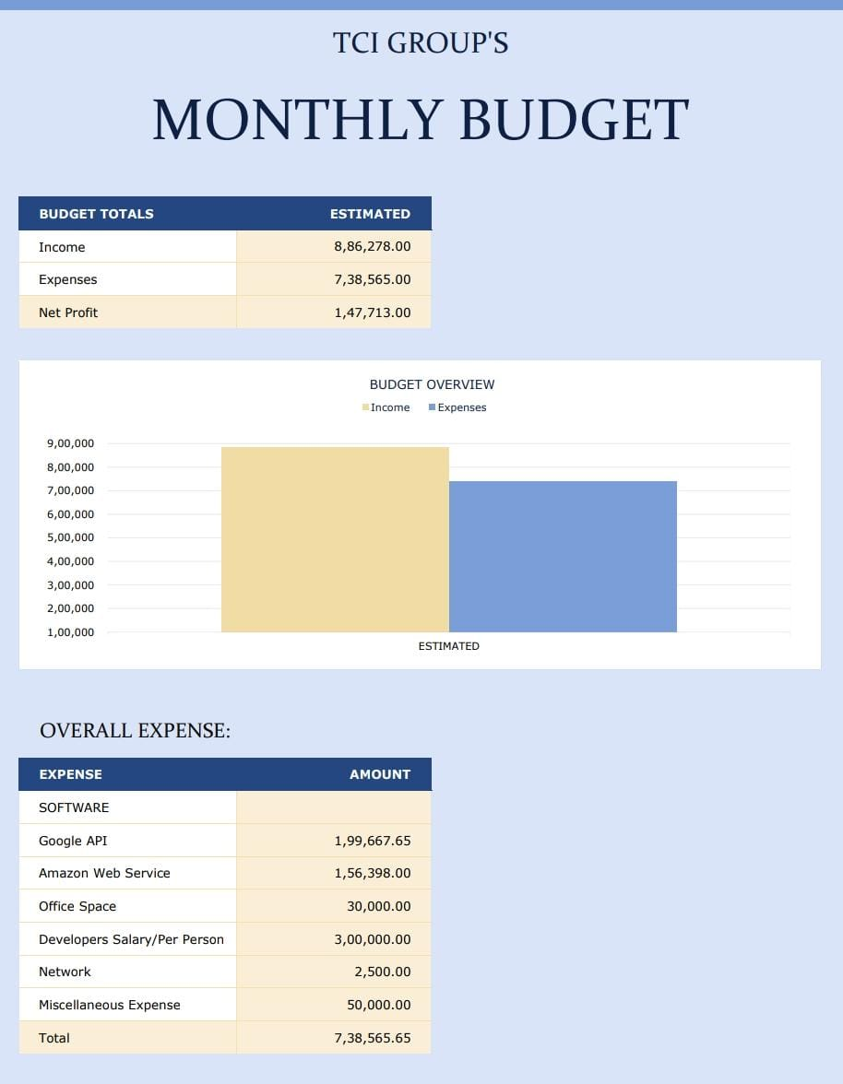

**Figure 7 Business Model with Profit Calculation**

**Conclusion**

Our project stands as a pioneering endeavor in revolutionizing the landscape of coal transportation. Through the implementation of the Coal Logistics Digital Platform, we've addressed longstanding challenges by amalgamating real-time data, advanced tracking, and comprehensive monitoring tools into a user-friendly interface.

Our platform not only bridges technological gaps in maritime, rail, and roadway coal transportation but also ensures transparency, efficiency, and compliance with safety and privacy regulations. By empowering stakeholders with informed decision-making capabilities, cost savings, and a paramount focus on safety, we've set a new standard in the industry.

As we conclude this project, our commitment remains unwavering—to continually enhance, adapt, and innovate. We envision a future where the coal transportation process is seamlessly streamlined, optimizing operations and fostering a safer, more efficient, and sustainable industry.